Alexander Abraham
Parallel Computing – Assignment 2

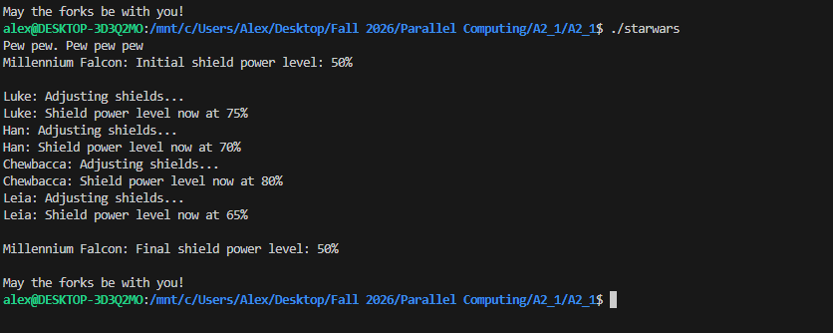
.c:
- Why does the initial and final value of the shield power remain unchanged? – The initial and final shield power remain at 50% because each child process receives its own copy of the shield_power variable when fork is called. Changes made by the children only affect their individual copies and doesn’t change the parents’ copy. The parent waits for the children to finish, but wait doesn’t transfer their changes back to the parent.

- Why does the order of output change every time you run the program? – The output order changes because the four child processes run concurrently, and the operating system decides when each process gets CPU time. The Scheduling can be different each time the program runs. The wait calls make the parent wait for all children to finish, but they do not determine the order in which the children execute.

Coding Task 3: Convert the sequential array sum program to parallel using
multiprocessing. Complete the parallel_sums.c program.
- Split the array into chunks of approximately equal size.
- Each child process should compute the sum of one chunk.
- Uses pipe() to send each child’s partial sum back to the parent
- Then the parent process:
o Waits for all children to finish
o Collects each partial sum from the corresponding pipe
o Calculate the total sum and print the result.
- Ensure all file descriptors are closed properly in both parent and child
Processes
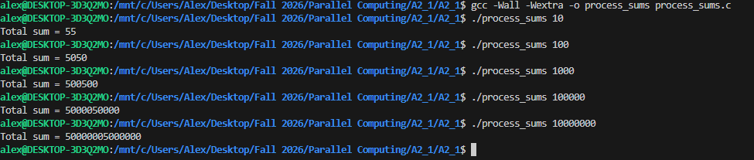

Task 4: Time both your sequential and parallel sums program for N = 100,000,000 and
fill out the table below. Then explain your observations in detail. What advantages and
challenges did you observe in multiprocessing.

Program | Sequential | 1 Process | 2 processes | 3 Processes | 4 Processes
Time Taken | 0m0.676s | 0m0.713s | 0m0.609s | 0m0.693s | 0m0.614s

Well, after stumbling through this last part of the assignment for awhile(it took me awhile to get the numbers accurately recorded) I have to say that I haven’t noticed that multiprocessing automatically makes a program faster.
I definitely see the point. By dividing up all of these tasks into smaller chunks, you can reduce the amount of time required for resource intensive work. From what I was reading, that is especially true when you can divide the work into manageable segments and it can be divided efficiently.
But there’s a lot of problems, too. Multiprocessing automatically takes time to set up. Creating child processes, making and using pipes, partial sum transference and then waiting on the child processes. All of these elements require additional time to create. The juice might not be worth the squeeze.
From what my system is telling me, the work required to create a multiprocessing system demonstrated that this particular project didn’t benefit from these additional processes. Indeed, it can even make a program slower.

